The Creature
by Alan Milson
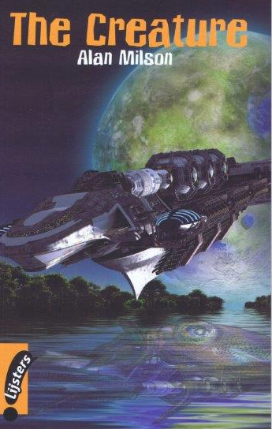

Assignments

Before Reading
- Look at the front cover of The Creature and describe what you see in the picture.

- Have a look at the back cover of your book.
A Write down the words that tell you that The Creature is a Science Fiction book.
B Explain in English: What are captors?
A

B

3 A Do you watch Science Fiction films or series?
B If so, what is your favourite Sci-Fi film or series?
C Explain why.
A
B

C

While Reading

Chapter 1 Star voyagers
- Why was Kin Zen one of the passengers aboard star ship Voyager?

- Look at the picture on page 7.
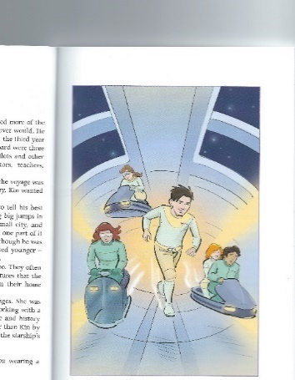What are the things that the people are driving called?

- They look like something from a fairground attraction.
What is the English word for this such a fairground car?
Use a dictionary.

- What animals are kept in the spaceship’s zoo?

- Why was Tesa aboard the spaceship?

6 A Describe or draw a tharmor.
B Read on and write down one of its features.
A

B

7 A What was the glass-like wall?
B How did this wall work?
A

B

8 What was the news that Kin told Tesa?

9 How did Tesa react to this news? Circle A, B, C or D.
A | She was happy for him. | C | She was disappointed.
B | She seemed jealous. | D | She did not care.

10 A What was the purpose of collecting creatures on different planets?
B Why was it important to do this?
A

B

Chapter 2 The mysterious planet

- How did the people feel when the Voyager was getting closer to Aldebaran 4?
(Happy/unhappy? Afraid/ excited, etc.)

- What did the scientists hope to find on Aldebaran 4?

- What form of life did they find at first sight?

- What was Kin’s job on Aldebaran 4?

5 A Why would the scientists be able to breathe without their helmets on?
B Why did they keep them on anyway?
A

B

6 What was special about the trees on Aldebaran 4?

7 A What did the cloud seem to be?
B What were these trying to do?
A

B

Chapter 3 Into the mountains

- What did Kin record at the beginning of this chapter?

- Describe the track that Maxxon saw.

- Commander Zen sent two robots ahead. What was the difference between the two?

- Suppose you had your own robot at your disposal, what would you like it to do?

- Did Kin disobey Commander Zen’s orders when he climbed down the ladder of the
explorer? Explain your answer.

- A Who was Neil Armstrong?
B One small step for a man is the first part of a famous quote* by him.
Finish this quote. Use the internet, if you like.
* A quote: what someone has said literally.
A

B

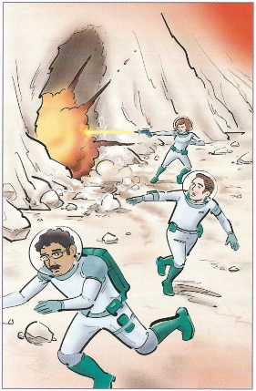7 A Who is who in the picture on page 18?
B What is happening in this picture?

A

B

Chapter 4 The creature

- Read the first two paragraphs of this chapter and draw the creature.

- Which of these statements is true? Circle A, B, C, or D.
A | The creature destroyed the robots and killed Utagao.
B | The creature killed Utagao but did not destroy the robots.
C | The creature destroyed the robots but did not kill Utagao.
D | The creature did not kill the robots and did not kill Utagao either.

- What caused the explorer to crash?

- When the creature turned back on the explorer and Maxxon, Kin distracted it by waving
his arms. Then Zen called out to Kin to get away.
Explain what is meant by: it was his mother’s voice, not a commander’s.

- How did Kin escape from the creature?

- Could he also save Maxxon?
YES | NO

Chapter 5 Danger comes on board

- What was done with the creature now?

- On his return to the Voyager Kin was having an energy drink.
A Do you drink energy drinks?
B If so, on what occasions do you drink them?
C What are the ingredients in these drinks that cause you to feel more energetic?
D What dangers of drinking too many energy drinks can you think of?
A
B
C
D

- What caused Kin to fall to the ground?

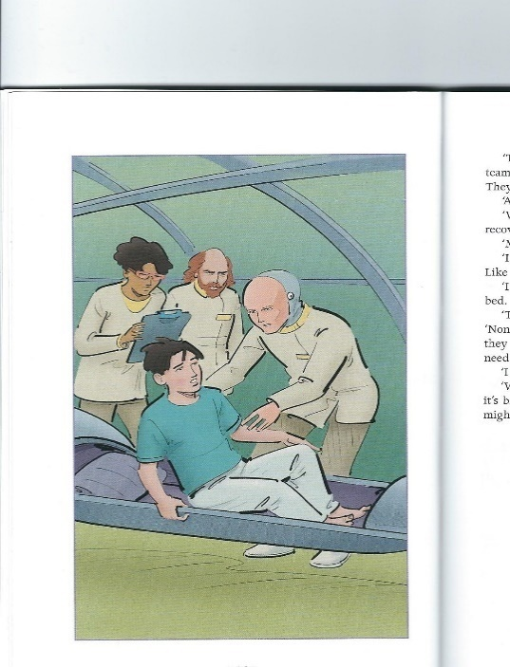
- Look at this picture from page 24.
A Who is the person on the right?
B What can you tell about his face?
C What had caused his face to be like that?
A
B
C

- What seemed to have happened to the others who came into contact with the creature?

- Look at the grid below.
On the left you see a list of body parts and certain objects.
On the right you see the possible results of when these body parts get into touch with these objects.
Now match the two lists.

 | body parts and objects |  | results
A | toe – jellyfish | I | bump
B | head – solid wall | II | blister
C | arm – cat’s nails | III | burns
D | heel – backside of a shoe | IV | pair of tweezers needed
E | armpit – tick (little black insect) | V | scratches
F | foot - splinter | VI | itching
G | hand - chemicals | VII | Lyme disease

A = | B = | C = | D = | E = | F = | G =

Chapter 6 Questions from the captain

- Read page 26. Write down the (combination of) words from the text that mean:

A apart from B way-in C part of a living organism
D (creature from) outer space E answer F frightening
A | B | C
D | E | F

- Who is Kov-Nuri and what did he do on board the spaceship?

- Who is Captain Tesjak?

- What is meant by “Captain Tesjak silenced the conversation”?

- What was the mystery that Jad Ur was talking about?

- What was the ray of hope that Captain Tesjak had?

- What memory did Kin compare his going ‘out’ with?

- What question did Captain Tesjak raise at the end of this chapter?

Chapter 7 In the zoo

- The anti-grav car stopped at the zoo’s outer door.
Both anti-grav and zoo are short for longer words. Write both words in full.
Anti-grav = | Zoo =

2 A Who is Dastar?
B What was Dastar not sure about?
C What did Dastar suggest about the creature’s origin?
A

B

C

- What can be concluded from the conversation between Kin and Kov-Nuri concerning
A the creature’s skin colour?
B the creature’s IQ?
C the creature’s possible state of mind?
D the creature’s physical condition?
A
B
C
D

- What did the creature do to itself?

- Why was it important to Kin and the people on board the Voyager for the creature to
stay alive?

Chapter 8 Kin and Tesa make plans

- Describe the effect that the Voyager’s jump into star speed had on
A Kin
B the creature
A
B

2 A What sort of homework was Tesa doing?
B Think of three more school subjects that pupils might take in the far future.
A
B | 1
B | 2
B | 3

3 What sometimes made life on the starship hard for Tesa?

4 What did Kin suggest about what caused the strange shapes and colours in her and
Tesa’s minds?

- How did Tesa and Kin get past the robot?

Chapter 9 Emergency in the zoo

- How was this creature different from any of the other zoo creatures?

- What did Kin want to stop the creature from doing?

- What happened when one of the robots wanted Kin to return to the other side of the
fence?

- What was Kin’s problem now? Explain your answer.

- What did Kin’s mind see when the force-field shut off?

- How did Kin’s feelings change when the robots attacked the creature?

- How did the robot keepers drive the creature back to its cage?

Chapter 10 Terrible decisions

- What had happened when the emergency warning sounded?

2 A What, according to Tesa, had the creature wanted to do before the robots
came?
B How had it wanted to do that?
A
B

3 Who were NOT hit when the force-field collapsed?

4 A What would the government do if Captain Tesjak brought an unknown
disease back to Epsilon?
B Copy the sentence that shows the policy behind this.
A
B

5 What is the second problem that Captain Tesjak is faced with?

- What was going to happen to the people who had fallen ill?

7 Look at this Science Fiction cartoon and explain the joke.
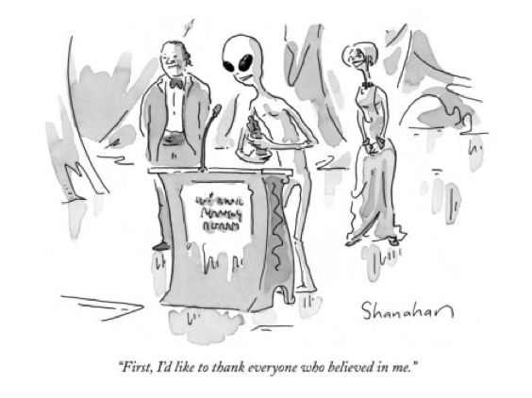

Chapter 11 Caught by the creature

1 How would the creature be destroyed if it attacked Kin?

- Was the fact that Kin had the best chance of surviving the real reason why Captain
Tesjak wanted Kin to go alone? Explain your answer.

- What did Captain Tesjak give Kin before he left?

- His stomach was in a knot.
Explain in English what this expression means.

- Below are some more expressions with body parts and their meanings. See if you can
match them.
 | expressions |  | meanings
A | to be all ears | I | to propose
B | to go on one’s knee | II | to get through a crowd of people
C | to elbow one’s way | III | to pretend not to see someone’s mistake
D | to go head over heels | IV | to listen carefully
E | to lose one’s hair | V | to become angry
F | to turn the other cheek | VI | to leave in haste
G | to turn a blind eye | VII | to refuse to take revenge

A = | B = | C = | D = | E = | F = | G =

- 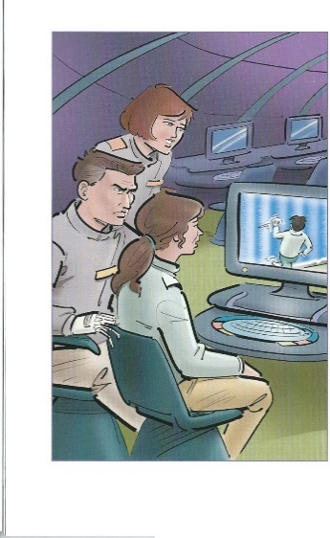Look at the picture on page 49.
What is happening in it?

- Why did Tesjak tell Jad Ur not to order his robots to shoot the creature?

8 What did Kin feel as he came closer to the creature?

9 What did the creature do with Kin at the end of this chapter?

Chapter 12 The Alien ship

- What order did Captain Tesjak give Jad Ur now?

- What made the ship shake violently?

- What did the creatures on board the alien ship want to do?

- What was the creature’s home?

- What had the creature wanted to do to Kin with its sucking tentacle?

- What had caused the creature’s feeling of loneliness on Aldebaran 4?

7 A What were the strange metal things that the creature had wanted to
communicate with?
B And what were the silver things?
A
B

Chapter 13 Tesa to the rescue

- What might happen to Kin if Jad Ur carried out her orders?

- What did the aliens’ thoughts tell Tesa in case the creature was not returned to them?

- What was the creature’s name?(!)

- Why did Kin stand in front of the creature when the robots appeared?

- At the end of this chapter, how do you think the story will end?

- Now that you know the creature’s name, have a look at the world’s longest place name:

Taumatawhakatangihangakoauauotamateaturipukakapikimaungahoronukupokaiwhenuakitanatahu

It is the Maori name for a hill in New Zealand and it means:

The summit where Tamatea, the man with the big knees, the slider, climber of mountains,
the land-swallower who travelled about, played his nose flute to his loved one.

And this is Europe’s longest place name:
Llanfairpwllgwyngyllgogerychwyrndrobwllllantysiliogogogoch

This village lies in Wales and it means:
Saint Mary's Church in a hollow of white hazel near the swirling whirlpool
of the church of Saint Tysilio with a red cave

Now describe your own town or village in the same way.

Chapter 14 Enemies or friends?

- What was the effect of the robots’ atomic guns?

- Why did the robots not stand a chance when Tesa and her friends attacked them?

- What had made Tesa and her friends so good at shooting?

- What was Kin’s biggest fear now?

- How were the environments on the humans’ side and the aliens’ side different from
each other?

- Why did the adult aliens not need to make contact to communicate?

- What were the aliens sorry for?

- Why did Kin not have to worry about the return journey anymore?

- Have a look at your answer to Question 3 again.
A Have you ever played any of these?
B What is your favourite (nor necessarily of this sort!)?
C Explain why this is your favourite.
A
B
C

After Reading
- Have a look at your answer to Question 5 of Chapter 13. Were you right?

- Below you can read the plot of one of the most successful Science Fiction films of all times: Star Wars, The Empire Strikes Back. Read the text and answer the questions.

The Empire is now chasing down and locating the Rebel Alliance, and they are hiding on frozen planet Hoth. Luke, Han, and Leia are all on Hoth. Luke gets lost in the snow and a vision of Obi Wan in a blizzard tells Luke to visit a Jedi master named Yoda. A probe droid from the Empire finds the base, and Darth Vader comes and destroys it. Han and Leia escape to Cloud City to find refuge with Han's homie Lando, and Luke travels to see Yoda and begins training, but leaves early because he senses that Vader catches up with Han and Leia... who then freezes Han in a cryogenic carbonite. Luke catches them and has a lightsabre battle with Vader, who cuts off Lukes hand after revealing that he is actually Luke's father. Luke escapes and he and Lando rejoin the Rebel Alliance who give Luke a mechanical cyborg hand.

A Find the words in the text that mean:

I snow storm II shelter III feels

IV making clear V gets away from VI get together again
I | II | III
IV | V | VI

B Explain in English or find another English word for these words from the text:

I homie II catches up with III actually

C Do you recognise some of the main Star Wars characters in this text?

Write down as many as you can recognise.

